Page | 1

# Candidate Enquiry Object:

|  |  |  |
| --- | --- | --- |
| *Field Name* | *Data Type* | *Value* |
| Candidate Information Section | | |
| Candidate Enquiry No | Auto Number | CE-{0000} |
| Candidate Name | Text, Required | 80 |
| Guardian | Pick list | Father, Mother, Husband, |

|  |  |  |
| --- | --- | --- |
|  |  | Guardian |
| Guardian Name | Text, Required | 80 |
| Community | Pick list | SC, ST, BC, OC, Muslim  Minority, Christian Minority, Others |
| Course | Look-Up | -NA- |
| Proofs Submitted | Multiple Pick list | Ration Card, Adhaar Card, PAN Card, Voter ID,  Passport, Driving License |
| Passport No. | Text | 30 |
| Gender | Pick list | Male, Female |
| Date Of Birth | Date | --NA-- |
| Age | Formula, Required | YEAR(Today())-YEAR(DOB) |
| Father Occupation | Text, Validation | Only Alphabets |
| Mother Occupation | Text, Validation | Only Alphabets |
| Family Annual Income | Currency | --NA-- |
| Educational Details Section | | |
| Educational Qualification | Pick list | SSC, Intermediate, Diploma, Degree, B.Tech,  MBA, MCA, PG |
| Year Of Pass | Pick list, Required | up to 1990 |
| Passed Out Organization | Text, Required | 100 |
| Contact Details Section | | |
| Mobile No | Phone, Required | --NA-- |

|  |  |  |
| --- | --- | --- |
| Address For  Correspondence | Text Area | --NA-- |
| Permanent Address | Text Area, Required | --NA-- |
| Father’s Mobile No | Phone | NA |
| Email | Email | NA |
| Course Information Section | | |
| Interested Course 1 | Pick list | Core Java, Cloud Computing, Oracle Financials, Oracle ADF, Oracle DBA, Spoken English, Communication Skills, Personality Development, Tailoring,  Yoga, Tally ERP |
| Interested Course 2 | Pick list | Core Java, Cloud Computing, Oracle Financials, Oracle ADF, Oracle DBA, Spoken English, Communication Skills, Personality Development, Tailoring,  Yoga, Tally ERP |
| Other Interested Course | Text | 100 |

Student Object:

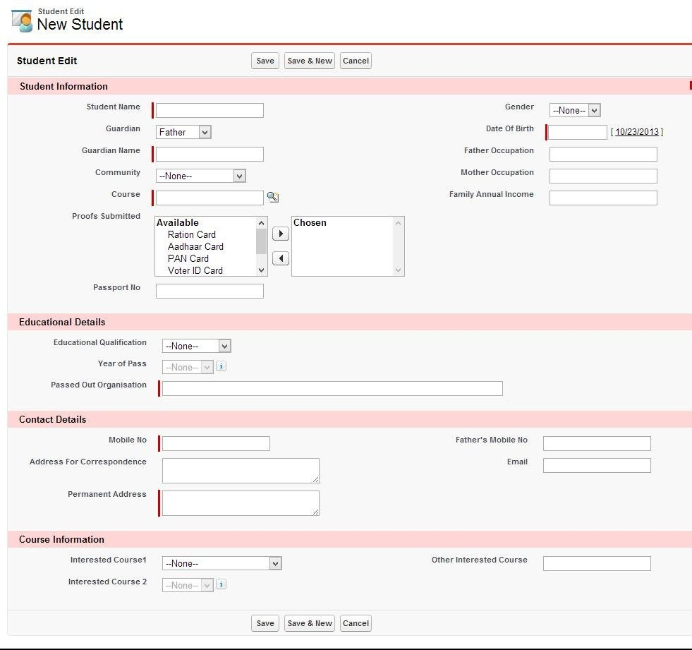

|  |  |  |
| --- | --- | --- |
| *Field Name* | *Data Type* | *Value* |
| Student Information Section | | |
| Student Name | Text, Required | 80 |
| Guardian | Pick list | Father, Mother, Husband,  Guardian |
| Guardian Name | Text, Required | 80 |

|  |  |  |
| --- | --- | --- |
| Community | Pick list | SC, ST, BC, OC, Muslim  Minority, Christian Minority, Others |
| Course | Master-Detail | -NA- |
| Proofs Submitted | Multiple Pick list | Ration Card, PAN Card, Voter ID, Passport,  Driving License |
| Passport No. | Text | 30 |
|  |  |  |
| Gender | Pick list | Male, Female |
| Date Of Birth | Date | --NA-- |
| Age | Formula, Required | Today()-DOB |
| Father Occupation | Text, Validation | Only Alphabets |
| Mother Occupation | Text, Validation | Only Alphabets |
| Family Annual Income | Currency | --NA-- |
| Educational Details Section | | |
| Educational Qualification | Pick list | SSC, Intermediate, Diploma, Degree, B.Tech,  MBA, MCA, PG |
| Year Of Pass | Pick list, Required | up to 1990 |
| Passed Out Organization | Text, Required | 100 |
| Contact Details Section | | |
| Mobile No | Phone, Required | --NA-- |
| Address For  Correspondence | Text Area | --NA-- |

|  |  |  |
| --- | --- | --- |
| Permanent Address | Text Area, Required | --NA-- |
| Father’s Mobile No | Phone | NA |
| Email | Email | NA |
| Course Information Section | | |
| Interested Course 1 | Pick list | Core Java, Cloud Computing, Oracle Financials, Oracle ADF, Oracle DBA, Spoken English, Communication Skills, Personality Development, Tailoring,  Yoga, Tally ERP |
| Interested Course 2 | Pick list | Core Java, Cloud Computing, Oracle Financials, Oracle ADF, Oracle DBA, Spoken English, Communication Skills, Personality Development, Tailoring,  Yoga, Tally ERP |
| Other Interested Course | Text | 100 |

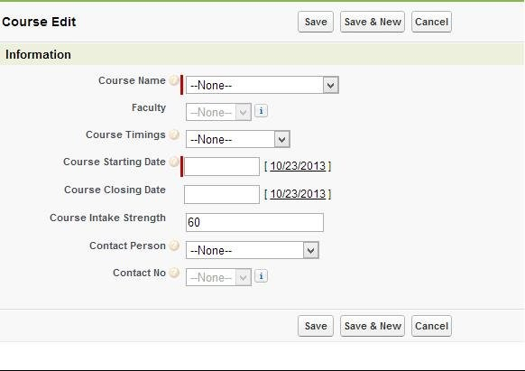Course – Object:

|  |  |  |
| --- | --- | --- |
| *Field Name* | *Data type* | *Value* |
| Course Id | Auto Number, Required | C Id-{0000} |
| Course Name | Pick List, Required | Core Java, Cloud Computing, Oracle Financials, Oracle ADF, Oracle DBA, Spoken English, Communication Skills, Personality Development, Tailoring,  Yoga, Tally ERP |
| Faculty | Pick list | --Pick list items-- |
| Course Timings | Pick list | --Pick list Items-- |
| Course Starting Date | Date, Required | --NA-- |
| Course Closing Date | Date | --NA-- |
| Course Intake Strength | Number, Default(60) | 60 |
| Registered Strength | Rollup Summery(on  Student) | --NA-- |

|  |  |  |
| --- | --- | --- |
| Course Duration | Formula | Course Closing Date-  Course Starting Date |
| Contact Person | Pick List | --Pick list Items-- |
| Contact No | Pick list | --Pick list Items-- |

Lab-Object:

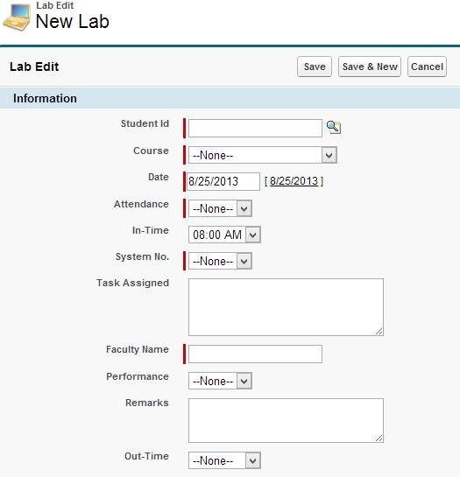

|  |  |  |
| --- | --- | --- |
| *Field Name* | *Data type* | *Value* |
| Lab No | Auto Number, Required | L-{00000} |
| Student Id | Master-Detail  Relationship, Required | Pick from list |
| Student Name | Formula, Required | Student Name(Student) |

|  |  |  |
| --- | --- | --- |
| Course | Pick list, Required | Core Java, Cloud Computing, Oracle Financials, Oracle ADF, Oracle DBA, Spoken English, Communication Skills, Personality Development, Tailoring,  Yoga, Tally ERP |
| Date | Date(Default-Today) | Select Date |
| Attendance | Pick list, Required | Present, Absent |
| In-Time | Pick list | Time Values |
| System No | Pick list | 1-25 |
| Task Assigned | Text Area(Long) | --NA-- |
| Faculty Name | Text, Required | 80 chars |
| Performance | Pick list | 10%,20%,…100% |
| Remarks | Text Area(Long) | --NA-- |
| Out-Time | Pick list | Time Values |

Attendance:

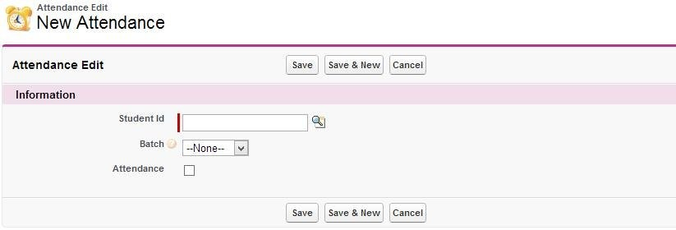

|  |  |  |
| --- | --- | --- |
| Attendance Id | Auto Number | A-{000} |
| Student Name | Master-Detail(Student) | Lookup |
| Batch | Picklist | Batch 1,Batch 2 |
| Attendance | Checkbox | Unchecked |

Validations:

1)On ‘Candidate Enquiry’ Object:

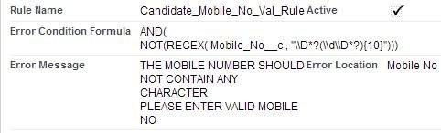Rule#1

Rule#2 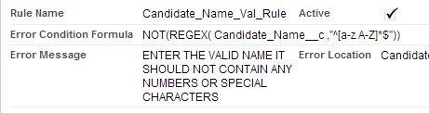 Rule#3 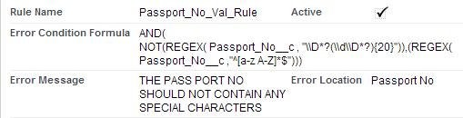

3)On ‘Student’ Object:

Rule#1 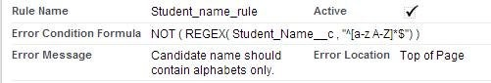 Rule#2 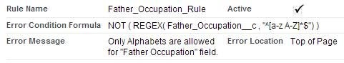

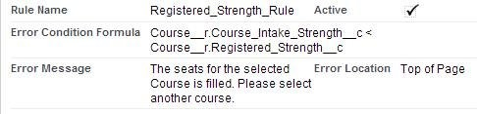Rule#3

Search Layouts for the Candidate Enquiry Object:

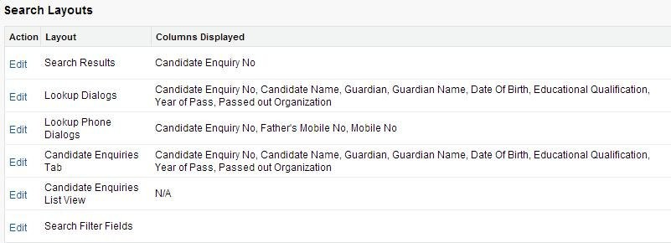

Search Layouts for the Student Objecct:

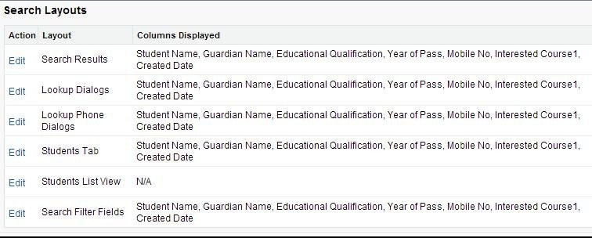

Search Layouts for the Course Objecct:

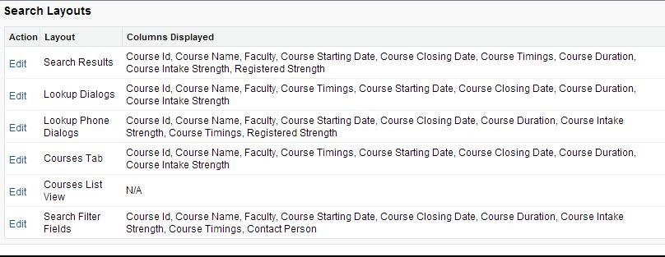

Search Layouts for the Lab Objecct:

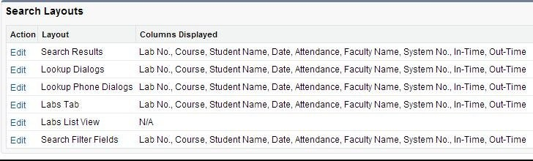

Search Layouts for the Attendance Objecct:

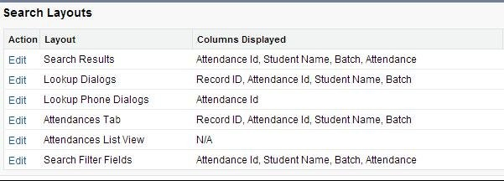

# WORK FLOW Rules

1)Sending Email to Faculties when student continuously absent for the lab for two days and when student present:

Email Template:

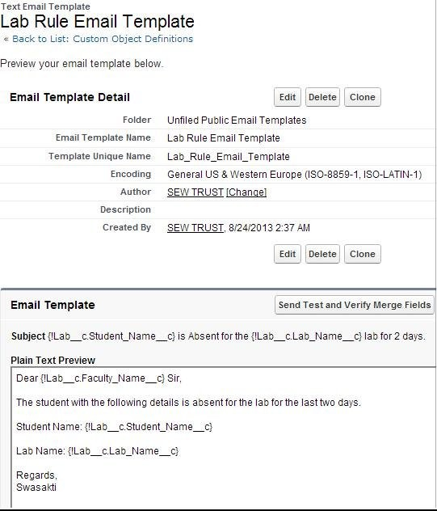

Workflow Rule:

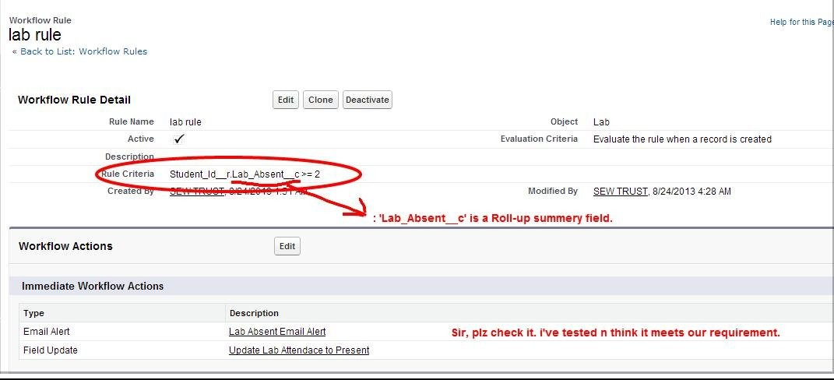

Updating has to perform on this workflow with the condition(Last Modified >2).

--------DEVELOPMENT PART---------

APEX TRIGGER FOR SENDING EMAILs to Candidate Email list when

a new course is created:

trigger newCourseEmail on Course c (after

insert){ list<String> emailid=new list<String>();

list<Candidate_Enquiry c> address1 =[select Candidate_Name c, Email c from Candidate_Enquiry c];

list<Messaging.SingleEmailMessage> singleEmailMessageList = new List<Messaging.SingleEmailMessage>();

for(Candidate_Enquiry c c:address1){

if(c.Email c != null){

emailid.add(c.Email c);

}

}

for(Course c obj: trigger.new){

Messaging.SingleEmailMessage m=new Messaging.SingleEmailMessage();

m.setToAddresses(emailid);

m.setSubject(obj.Course_Name c +' is starting');

m.setPlainTextBody('Dear '+ 'Candidate' +', The following course is starting shortly in our institute.'+

' '+

'Course Name: '+ obj.Course_Name c+

'Course Starting Date :'+obj.Course_Starting_Date c+

'Course Closing Date: '+obj.Course_Closing_Date c+

'Course Duration: '+obj.Course_Duration c+

'Faculty :'+obj.Faculty c+

' '+

' Regards,Swasakti.');

singleEmailMessageList.add(m);

}

if(singleEmailMessageList != null && singleEmailMessageList.size() >

0){ Messaging.sendEmail(singleEmailMessageList);

}

}

**Developing a Visualforce Page to Access the Students and to Process the Daily Attendance:**

<apex:page standardController="Student c" extensions="xyz" recordSetVar="student" tabstyle="Student c" showHeader="false" sidebar="false">

<apex:sectionHeader title="SWASAKTI" subTitle="Students Attendance

System"/> <apex:form >

<center>

<apex:outputLabel >Course :</apex:outputLabel>

<apex:selectList id="one" size="1">

<apex:selectOption itemValue="Cloud Computing" itemLabel="Cloud

Computing"/> <apex:selectOption itemValue="Core Java" itemLabel="Core

Java"/> <apex:selectOption itemValue="Tailoring" itemLabel="Tailoring"/>

<apex:selectOption itemValue="Oracle Financials" itemLabel="Oracle

Financials"/> <apex:selectOption itemValue="Oracle ADF" itemLabel="Oracle

ADF"/> <apex:selectOption itemValue="Oracle DBA" itemLabel="Oracle DBA"/>

<apex:selectOption itemValue="Spoken English" itemLabel="Spoken English"/>

<apex:selectOption itemValue="Communication Skills" itemLabel="Communication Skills"/>

<apex:selectOption itemValue="Personality Development" itemLabel="Personality

Development"/> <apex:selectOption itemValue="Yoga" itemLabel="Yoga"/>

<apex:selectOption itemValue="Tally ERP" itemLabel="Tally

ERP"/> </apex:selectList></center>

<apex:pageBlock >

<apex:pageBlockSection >

<apex:pageBlockTable id="two" value="{!student}" var="a" columnsWidth="50px,50px" cellpadding="14" border="4">

<apex:column value="{!a.Name}"/>

<apex:column headerValue="Attandance">

<apex:inputCheckbox value="{!a.Name}">

<apex:actionSupport event="onClick" action="{!GetSelected}"

rerender="Selected_PBS"/> </apex:inputCheckbox>

</apex:column>

</apex:pageBlockTable>

</apex:pageBlockSection>

<center><apex:commandButton value="Save"/></center>

</apex:pageBlock>

</apex:form>

</apex:page>

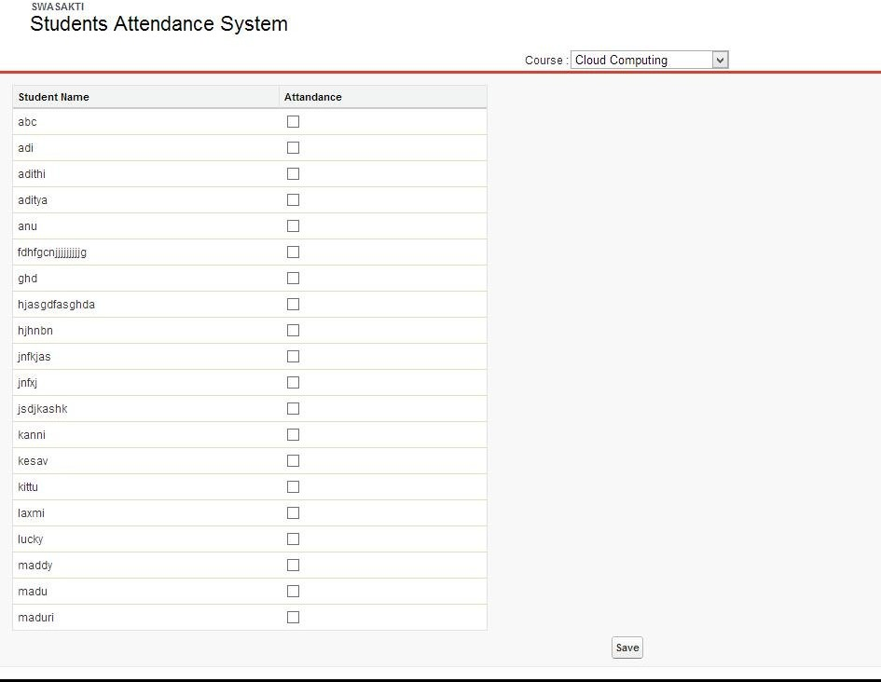

**Moving a Record from Candidate Enquiry to the Student Object:**

## For this we have done several steps,

1. **Goto Candidate Enquiry list and Click on the record you want to move from Candidate Enquiry to the Student Object, as shown below.**

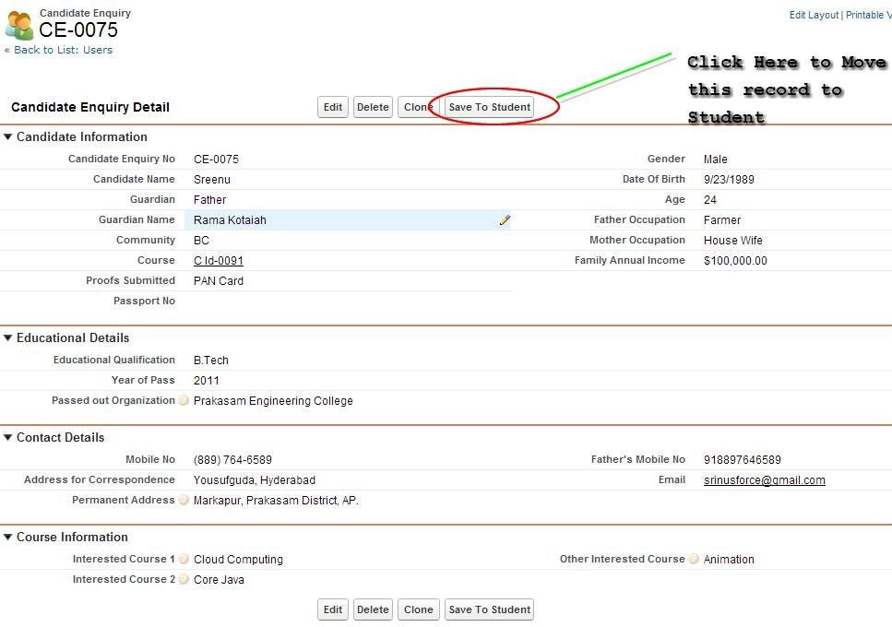

**Create a Visualforce Page to Hold this data and Redirect to the Student object,**

<apex:page StandardController="Candidate_Enquiry c" Extensions="redirect_student">

<apex:sectionHeader title="Candidate Enquiry Edit" subtitle="New Candidate Enquiry"/> <apex:form >

<apex:outputLink value="{!URLFOR($Action.Candidate_Enquiry c.New)}">

<h4>Create New Candidate</h4>

</apex:outputLink>

<apex:pageBlock >

<apex:pageBlockSection title="Candidate Information" collapsible="false">

<apex:inputField value="{!Candidate_Enquiry c.Candidate_Name c}"/>

<apex:inputField value="{!Candidate_Enquiry c.Gender c}"/>

<apex:inputField value="{!Candidate_Enquiry c.Guardian c}"/>

<apex:inputField value="{!Candidate_Enquiry c.Date_Of_Birth c}"/>

<apex:inputField value="{!Candidate_Enquiry c.Guardian_Name c}"/>

<apex:inputField value="{!Candidate_Enquiry c.Father_Occupation c}"/>

<apex:inputField value="{!Candidate_Enquiry c.Community c}"/>

<apex:inputField value="{!Candidate_Enquiry c.Mother_Occupation c}"/>

<apex:inputField value="{!Candidate_Enquiry c.Course c}"/> <apex:inputField value="{!Candidate_Enquiry c.Family_Annual_Income c}"/>

<apex:inputField value="{!Candidate_Enquiry c.Proofs_Submitted c}"/><br></br>

<apex:inputField value="{!Candidate_Enquiry c.Passport_No c}"/>

</apex:pageBlockSection>

<apex:pageBlockSection title="Educational Details" collapsible="false" columns="1">

<apex:inputField value="{!Candidate_Enquiry c.Educational_Qualification c}"/>

<apex:inputField value="{!Candidate_Enquiry c.Year_of_Pass c}"/>

<apex:inputField value="{!Candidate_Enquiry c.Passed_out_Organization c}"/>

</apex:pageBlockSection>

<apex:pageBlockSection title="Contact Details" collapsible="false">

<apex:inputField value="{!Candidate_Enquiry c.Mobile_No c}"/>

<apex:inputField value="{!Candidate_Enquiry c.Father_Mobile_No c}"/>

<apex:inputField value="{!Candidate_Enquiry c.Address_for_Correspondence c }"/>

<apex:inputField value="{!Candidate_Enquiry c.Email c}"/>

<apex:inputField value="{!Candidate_Enquiry c.Permanent_Address c}"/>

</apex:pageBlockSection>

<apex:pageBlockSection title="Course Information" collapsible="false">

<apex:inputField value="{!Candidate_Enquiry c.Interested_Course_1 c}"/>

<apex:inputField value="{!Candidate_Enquiry c.Other_Interested_Course c}"/>

<apex:inputField value="{!Candidate_Enquiry c.Interested_Course_2 c}"/>

</apex:pageBlockSection>

<center> <apex:commandButton action="{!records}" value="SAVE to student"/> </center>

<center><apex:commandButton action="{!redirect}" value="go" timeout="200"/></center>

</apex:pageBlock>

</apex:form>

</apex:page>

Controller:

public class redirect_student

{

String recordId;

public redirect_student() {

}

public redirect_student(ApexPages.StandardController controller)

{

//recordId = controller.getId();

}

public static void records()

{

saveRecord();

PageReference save;

}

public static void saveRecord()

{

List <Candidate_Enquiry c> ce =[select id, Address_for_Correspondence c, Age c, Candidate_Name c, Community c, Course c, Date_Of_Birth c,

Educational_Qualification c,

Email c, Employment_Registration_No c, Employment_Status c, Family_Annual_Income c, Father_Mobile_No c,

Father_Occupation c, Gender c, Guardian c, Guardian_Name c, Interested_Course_1 c, Interested_Course_2 c,

Martial_Status c, Mobile_No c, Mother_Occupation c, Other_Interested_Course c, Passed_out_Organization c,

Passport_No c, Permanent_Address c, Proofs_Submitted c, Year_of_Pass c from Candidate_Enquiry c where id=:ApexPages.currentPage().getParameters().get('ID')];

List<Student c> stu=new List<Student c>(); Student c s;

for(Candidate_Enquiry c c : ce)

{

s = new Student c(Name=c.Candidate_Name c, Address_For_Correspondence c=c.Address_for_Correspondence c,

Community c=c.Community c, Course c=c.Course c, Date_Of_Birth c=c.Date_Of_Birth c,

Educational_Qualification c=c.Educational_Qualification c, Email c=c.Email c,

Family_Annual_Income c=c.Family_Annual_Income c, Father_Mobile_No c=c.Father_Mobile_No c,

Father_Occupation c=c.Father_Occupation c, Gender c=c.Gender c, Guardian c=c.Guardian c,

Guardian_Name c=c.Guardian_Name c, Interested_Course1 c=c.Interested_Course_1 c,

Permanent_Address c=c.Permanent_Address c, Year_of_Pass c=c.Year_of_Pass c,

Passport_No c=c.Passport_No c, Proofs_Submitted c=c.Proofs_Submitted c, Interested_Course_2 c=c.Interested_Course_2 c,

Other_Course_Interested c=c.Other_Interested_Course c,

Mobile_No c=c.Mobile_No c, Mother_Occupation c=c.Mother_Occupation c, Passed_Out_Organisation c=c.Passed_out_Organization c );

stu.add(s); database.insert(stu); delete ce;

}

}

public PageReference redirect()

{

try {

PageReference customPage = new PageReference

('https://ap1.salesforce.com/a00?fcf=00B90000004OTGB');

customPage.setRedirect(true);

// customPage.getParameters().put('id', recordId); return customPage;

}

catch (DMLException e)

{

ApexPages.addMessage(new ApexPages.message(ApexPages.severity.ERROR, 'Error creating new account.'));

return null;

}

}

}

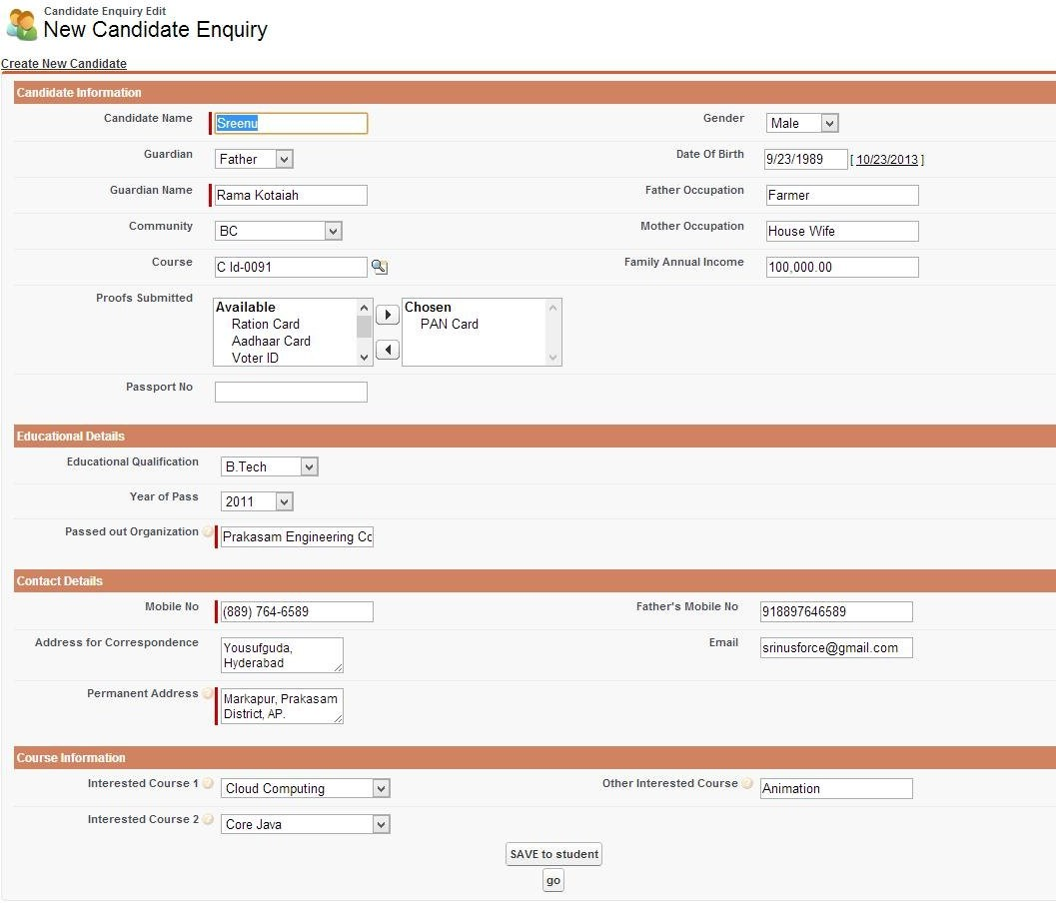

Then, Click on the ‘Save To Student’ button, after reload the page immediately click on the ‘GO’ button. Then, the record is moved to the Student object and saved.

The Entire project will cover majorly, three scenarios.

* 1. Moving record from Candidate Enquiry to Student.
  2. Sending Emails to all Candidates when a new course is created.
  3. Sending Emails to Faculty when student being absent for the lab for more than 2 days. 4)Attendance System.